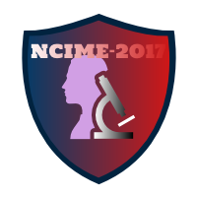

**Guidelines for Listeners/ Attendee**

1) Those who want to only attend the conference need to register online. ([www.ncime.com](http://www.ncime.com))

2) Listeners will get all the benefits of the conference including admission to all sessions, conference kit, Tea, Breakfast, Lunch, conference proceedings (soft copy), Lonavala site tour, free accommodation and one side travelling allowance.

3) Listeners need to register online directly by paying given fees.